
School Emergency
Security & Crisis Plan


School Emergency Security & Crisis Plan

The safety of our students, staff, schools and communities is paramount. When a school and District plans how it will respond to an emergency that presents a threat, it is more likely that the incident can be handled in an organized and timely manner.
- Share the plan with all staff to ensure understanding of proper procedures
- Review the communications process for reporting incidents
- Submit follow-up reports and information using the proper forms

District Wide Communication Tree (Crisis = Call)
Every minute matters.
Superintendent
Dr. Feagins
Jermaine Johnson Communications
Tito Langston
901-205-4008

Security 416-5773

Principal/District Office

**PLEASE CALL SECURITY FIRST

School Communication Tree (Crisis = Call)
Every minute matters.

Tito Langston
901-205-4008

Security
416-5773

Principal

Teacher/Staff Member

**PLEASE CALL SECURITY FIRST

Reporting & Managing Incidents

Dr. Marie Feagins, Superintendent
- Authorize the release of information to the public and ultimate closure of school.
- Keep School Board informed of emergency status.

Mr. Jermaine Johnson, Strategic Communications Officer
- Create and disseminate draft messages, robo-call for principals related to the crisis.
- Communicate with Legal to ensure accurate and timely information is provided to families, schools, media, and District personnel.

Reporting & Managing Incidents

Tito Langston, Assistant Superintendent of Business Operations
- Communicate crisis directly to the Superintendent and the Senior
Leaders immediately upon knowledge of the crisis, as soon as safely possible.

Security, Command Center
- Coordinate and direct the contact with emergency medical services, local
police, and Sheriff’s departments, fire departments, and the highway patrol.

All Principals
- Communicate details to Safety & Security(first) followed by Assistant Superintendent, Tito Langston immediately upon knowledge of the crisis, as soon as safely possible.

Reporting & Managing Incidents

Principals should follow the reporting process to immediately communicate the incidents listed below and any activity that could garner media attention:
- Active Shooter *
- Bomb Threat *
- Contraband
- Fire
- Medical Emergency
- Melee (five or more persons)
- Missing Student(s)
- Narcotics
- Person Brandishing Weapon
- Social Media Threat
- Weapon on Campus

Reporting Incidents

- Time is of the essence: Assess the situation and determine if it is an emergency.
- Call Security at (901) 416-5773 first. Call Tito Langston, Assistant Superintendent of Business Operations (901) 205-4008 to report the crisis.
  - Principal/Designee must approve the phone call to (901) 416-5773 when safe to do so.
  - Calls should be made by the Security Officer & Tito Langston (Assistant Supt. Of Business Operations)
  - Security will communicate if additional officers will be provided.
- Follow the Communications Tree
- Complete Incident Form
- Send Approved Robo Call (when necessary)
Clearly Communicate the Facts:

- Who is involved?
- What happened?
- When did the incident happen?
- Where did the incident happen?
- Why did the incident happen?
- Additional beneficial information
*Be sure to share if the student has an exceptionality:
  - Provide pertinent information including if the student is sensitive to loud sounds, touch, etc.


Next Steps

Next Steps:
    - Create a Crisis Communication Tree for Your Campus
    - Present Crisis Communication Tree update during Staff Meeting

Professional Development Dates:
      - October 24, 2024
      - November 14, 2024


Procedures to Response

Presenters:

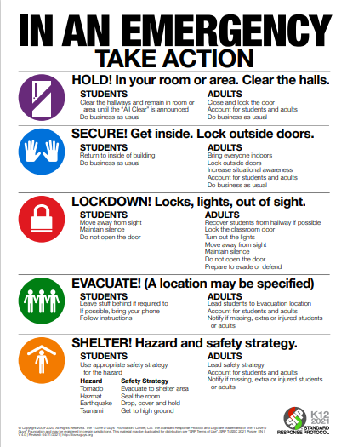Functional Procedures/Emergency Commands

A set of standards, clear directives that can be implemented across a variety of emergency situations. When the emergency begins, the school administrator will decide upon the appropriate Functional Emergency Procedure to implement. See below examples:

Evacuate: “Evacuate the Building”
Lockdown: “Lockdown, Lockdown”
Shelter-in-Place: “Clear the Halls and Shelter-in-Place”
Room Clear: “Clear this room and go to ”
Get Inside: “Go Inside Now”
Drop: “Take cover under a nearby desk or table away from windows”

Functional Procedures/Emergency Commands

1. Evacuation
An orderly and preplanned exit from the district facility when
conditions are safer outside than inside

When announcement is made, or alarm sounded:
- Take the closest and safest way out as posted
  - Use secondary route if primary route is blocked or hazardous
- Do not stop for student/staff belongings
- Take class attendance log for student accounting
- Go to designated assembly area
- Check for injuries
- Assist those needing special assistance
- Wait for further instructions

2. Get Inside
For use when conditions inside are safer than outside.

When announcement is made or alarm sounded:
- Move students/staff inside as quickly as possible
- Assist those needing special assistance
- Report to designated assembly area
- Check for injuries
- Account for all students, staff and visitors
- Wait for further instructions

Functional Procedures/Emergency Commands

3. Soft Lockdown (LOCKOUT)
A situation where there is potential for a threat and the school are to take protective measures without ceasing instructional time.
When the announcement is made:
- All exterior doors to the building remain locked
- All entrance doors will be monitored closely via the Aiphone System in place, and by designated school staff
- Assist those needing special assistance.
- Only law enforcement agencies are allowed to enter the building Students and school personnel outside should be relocated within the building.
- Limit movement throughout building until given the all-clear.

4. Lockdown
A situation where there is an imminent threat inside or outside of the building. Students are to immediately go to a protective place/position
When the announcement is made:
- Call 911 and Safety and Security (901-416-5773). Give description and location of subject
- Students and Staff are to be cleared from the halls immediately and
to report to nearest available room
- Assist those needing special assistance
- Close and lock all windows and doors and do not leave
- BE QUIET! (Silence Mobile Devices)
- Turn off lights
- Use interior walls to position students away from the threat to minimize visibility from windows and doors
- Sit on floor
- Wait for further instructions

Functional Procedures/Emergency Commands

5. Drop, Cover, and Hold
For use in earthquake or other imminent danger to building or
immediate surroundings.

When the command “Drop” is made:
- DROP – to the floor, take cover under a nearby desk or table and face away from the windows
- COVER - your eyes by leaning your face against your arms
- HOLD - on to the table or desk legs, and maintain present location/position
- Assist those needing special assistance
- Wait for further instructions

6. Room Clear
For use when staff needs to remove students immediately from the classroom or area because the environment is unsafe. (Example - student medical or behavioral emergency.)

When the command “Clear the room” is made:
- Walk to the directed location
- Stay quiet and orderly while moving in the hall and entering the other location
- Follow the directions of the staff person in charge
- Assist those needing special assistance
- Wait for further instructions

Functional Procedures/Emergency Commands

7. Shelter-in-Place
Placement of students in a pre-determined area of the building’s
interior due to an external gas or chemical release

When the announcement is made follow the Lockdown procedure with the addition below:
- Close all windows and doors and seal the gap between bottom of the door and the floor (external gas/chemical release) using available materials such as coats, blankets, or rugs

FIRE/EXPLOSION

Usable Command
“Evacuate Now”

Fire alarm notification indicates immediate EVACUATION from the building using specified exit routes. Use alternate route(s) if
primary route(s) is obstructed or dangerous.
Call 911 and Safety and Security (416-5773).
Assist movement of students and staff with special needs.
Shutdown appropriate utility and building systems.
Account for all students, visitors, and school personnel.
Take rosters and roll books to outside assembly area.

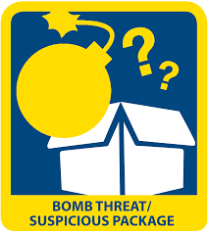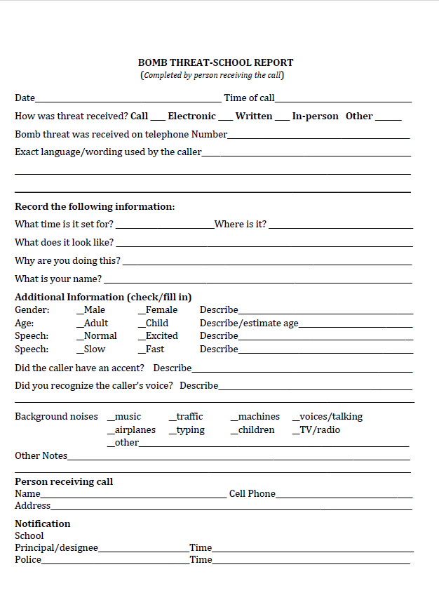BOMB THREAT
Usable Command
“Evacuate Now”

Gather as much information as possible, noting the caller ID
number and the phone line that they called in on.
Make appropriate notifications: 911, Safety and Security (416- 5773), SRO and active SERT.
- Determine whether Shelter-In-Place or Evacuation action is appropriate and execute.
- Assess the credibility of the threat by search of area(s)
- If suspicious item is found Do not touch it.
If appropriate, EVACUATE the building.
Provide assistance to students and school personnel with special needs.
Account for all students, visitors, and school personnel.
Activate relocation plan if needed.

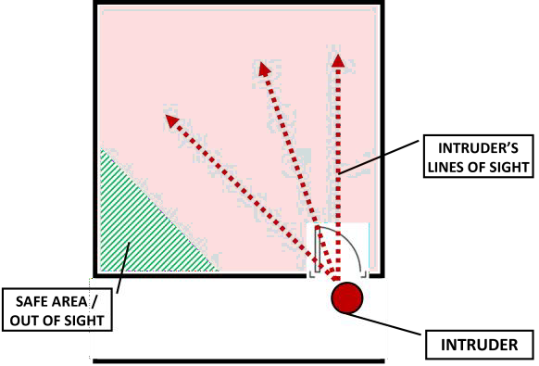ACTIVE AGGRESSOR / ACTIVE SHOOTER
Depending on the situation, initiate LOCKDOWN or EVACUATION using the appropriate Emergency Command.
*Safer inside = Lockdown
Usable Commands “Lockdown” “Evacuation” “Get Inside”
“Hide”
*Safer outside = Evacuation

Call 911 and Safety and Security (416-5773). Give description
and location of subject . Provide as many details as possible.
All movement in the building stops. Remain calm and quiet.
Follow directions from law enforcement.
Account for all students, visitors, and school personnel.

SEVERE STORMS
Usable Command “Shelter in Place” “Get Inside”
“Drop, Cover, and Hold”

Upon notification, students and school personnel move to their
identified SHELTER IN-PLACE location. (Lowest floor of building away from windows and doors that could blow open.
Assist in the movement of students and staff with special needs.
Make appropriate notifications (911 & Safety and Security (416-
5773).
Account for all students, visitors, and school personnel.

EARTHQUAKE
Usable Command
“Drop, Cover, and Hold”

If inside:
Upon shaking, “DROP, COVER, and HOLD”.
Assist students and school personnel with special needs.
Shutdown appropriate utility and building systems.
Evacuate to predesignated area, away from power lines and
structures.
Account for all students, visitors, and school personnel.

If outside:
- Move quickly away from the building and overhead
electrical wires
- Lie flat, face down, and wait for shocks to subside.
- Follow standard student accounting procedures.
- Do not attempt to enter the building until authorized to do so.
- Do not light fires or touch down power lines.

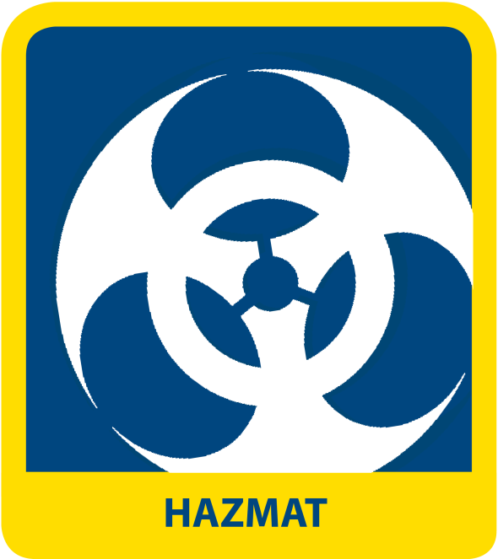HAZARDOUS MATERIALS RELEASE

Usable Command “Shelter in Place” “Get Inside”
“Drop, Cover, and Hold”

Determine which action is most appropriate for the situation:
SHELTER-IN-PLACE or EVACUATION.
If EVACUATION: move students in the opposite direction of the
wind and at least 500 ft. away from hazardous source.
If EVACUATION: Assist in the movement of students and staff
with special needs.
If SHELTER-IN-PLACE: Shutdown appropriate utility and building
systems.
If SHELTER-IN-PLACE: close classroom windows and seal gaps
under doorways.
Account for all students, visitors, and school personnel.


Please email for reponses to additional questions.

Jimmy D. Tuggers MSCS - Emergency Management Advisor tuggersj@scsk12.org

Quentin Reed
MSCS - Special Project Assistant reedq1@scsk12.org

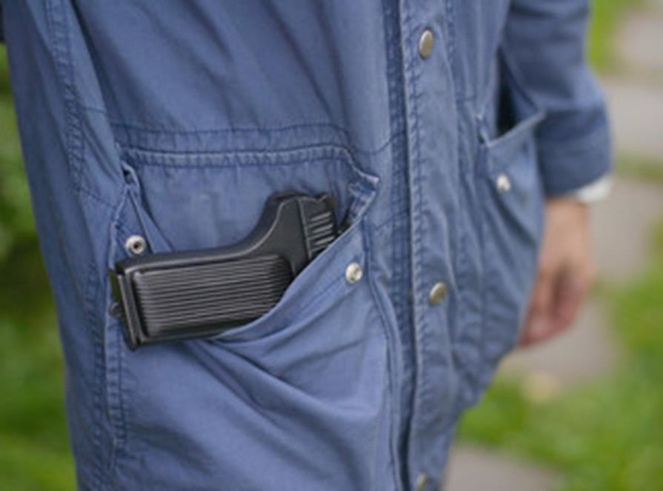Managing Student Fights

Visual Screening
- Identify the dominant hand
- Look for weapons
- Waist band
- Look for out of place clothing
- Sag in jacket
- Confirmation weapon touch
- Blading
- Unnatural gait: not swinging arm
- Bulges in clothing

Managing Student Fights

Intervention Rules
- Keep your eyes on the group
- Be aware of the mob mentality
- Don’t become part of the fight
- Bystanders can become a threat
- Age doesn’t matter, behavior does

Managing Student Fights

Fight Intervention
- Tie back long hair
- Remove loose items like ties, watches, necklaces, or other jewelry. Take off your glasses, too, if you can manage without them.
- Never get between students while they are throwing punches.
Approach them from cautiously from behind.
- When the time is right, have school staff members physically separate the fighting students. Make sure to use your entire body, not just your hands, and avoid turning your back on the situation.
- Don’t try to control only one student. Focus on both parties. By restraining only one side, you run the risk of putting that student in danger, as the other student will have an opportunity to strike

Managing Student Fights

Document the Occurrence
- Relocate to the administrative office
- Document in writing
- Inform staff members

Contraband on School Campuses

Training Goals & Objectives
- Review local, state, and federal student- related court cases and discuss rulings.
- Develop a list of cases that are applicable to school that will serve as presentation topics for students, parents, and staff that promote safety.
- Explain the correlation between landmark student-related court decisions and the responsibilities and involvement of the SRO and liabilities.

Contraband on School Campuses

What is constituted as contraband?

The following are just a few, but not limited to...

Drugs Tobacco Alcohol
Weapons of any form

Any items prohibited by the school board (cell phones, laser pointers, etc)
  - Pornographic Materials
  - Needles

Contraband on School Campuses

Lessons for Schools
- Be Proactive
- Train
- Notice
- Document

Contraband on School Campuses

Educators and the SRO-Collaboration
&

Fourth Amendment
  - TLO and Reasonable Suspicion
  - School Official
  - Outside Law Enforcement

Contraband on School Campuses

Lockers
    - Commonwealth v. Cass
    - In re Patrick Y.

Drug Dogg Sniff
    - U.S. v. Place

Nature of Intrusion
& Expectation of Privacy

    - Horton v. Goose Creek School Dist.
    - U.S. v. Ludwig

Strip Searches
    - Konop v. Northwestern School Dist.
    - Holding
    - Facts
    - Rationale

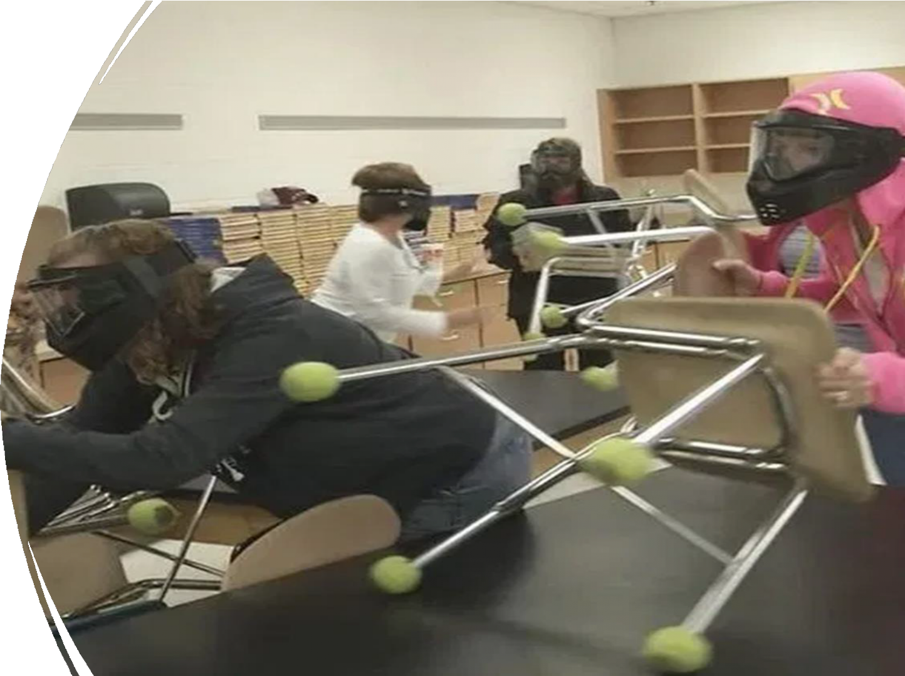

Active Shooter
Response
- An active shooter is an individual who is engaged in killing, or attempting to kill, people in a confined and populated area.
- Often unpredictable and evolve quickly
- Amid the chaos, anyone can play an integral role in mitigating the impacts of an active shooter incident.
- Usually, no pattern or method to the selection of victims
by an active shooter
- Often over within 10 to 15 minutes - before law enforcement arrives on the scene
- Individuals must be prepared both mentally and physically to deal with an active shooter situation.
- What should people do in the case of an active shooter
attack?

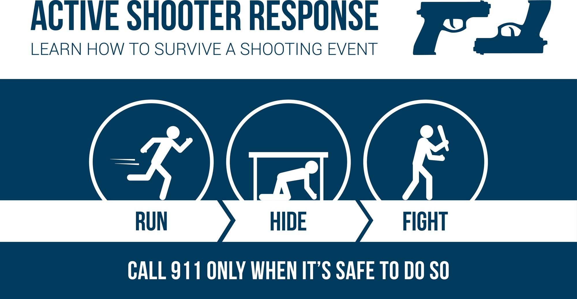



Responding to Social Threats

- At the conclusion of this instruction, the student shall be able to:
  - Establish a multidisciplinary threat assessment team
  - Define concerning and prohibited behavior
  - Create a central reporting mechanism
  - Determine the threshold for law enforcement intervention
  - Develop risk management options
  - Create and promote safe school climate

Responding to Social Threats

Comprehensive Targeted Violence Prevention Plan
- Physical security
- Emergency management
- Violence prevention efforts

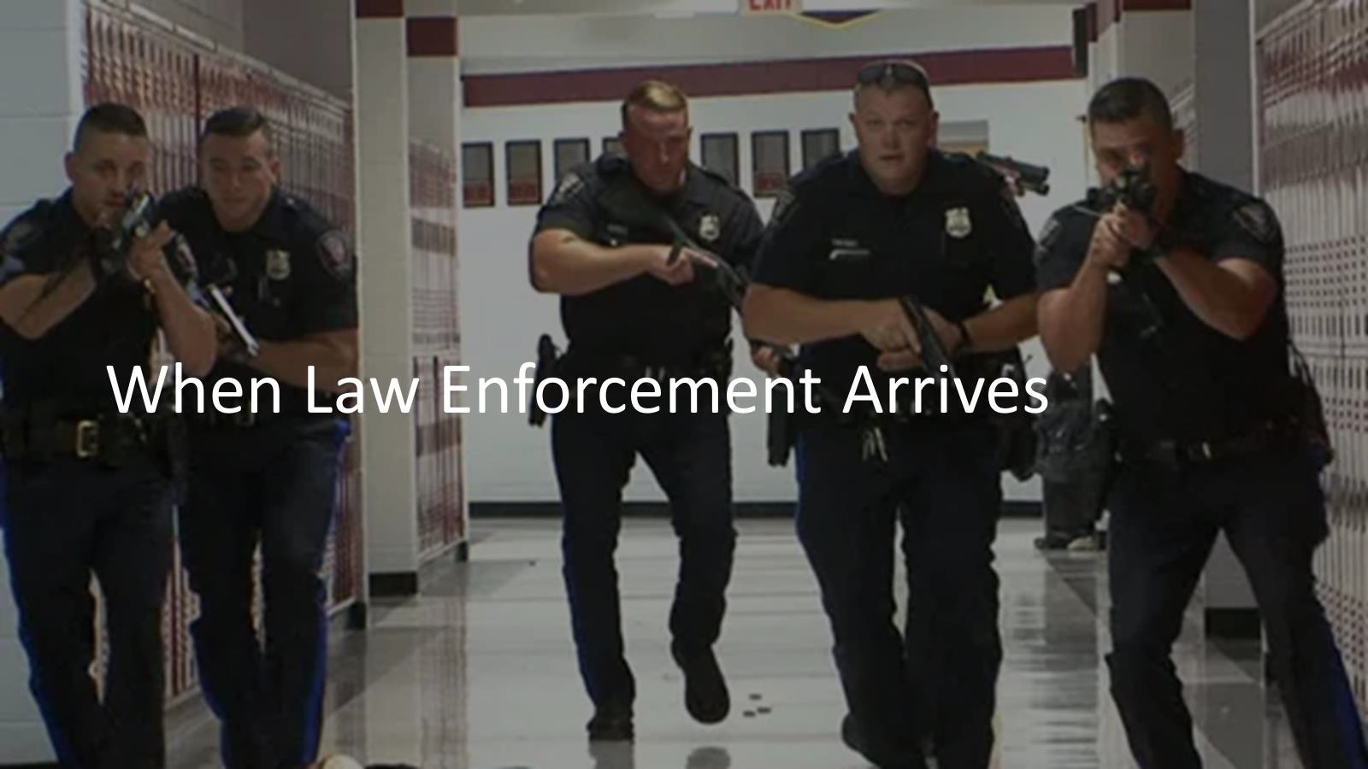

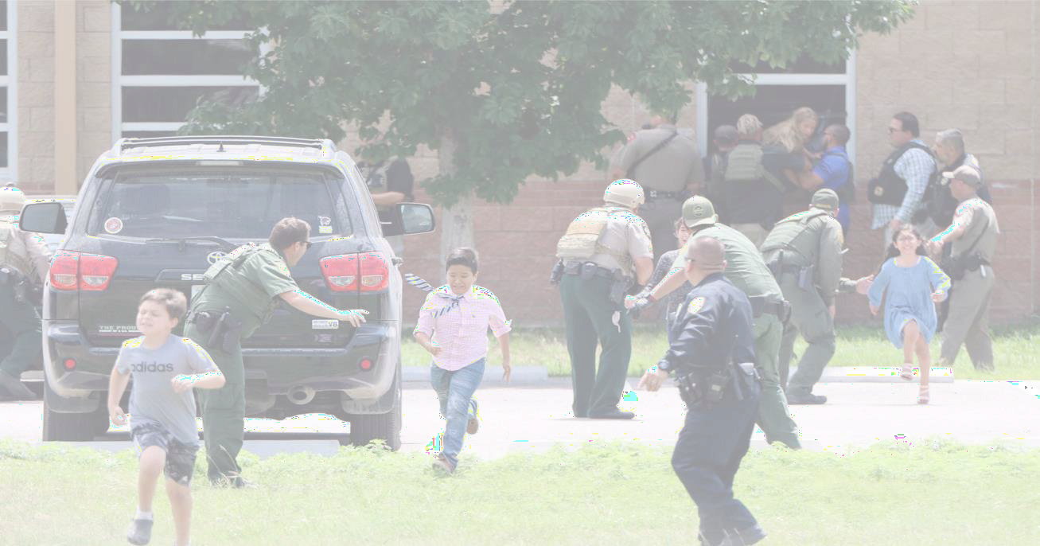Responding to Social Threats

Safe School Initiative Key Findings

  - No student profile, could be Male and female
  - High achieving students
  - Loners and socially isolated, well liked and popular
  - Attacks are rarely sudden or impulsive
  - Attackers did not directly threaten target
  - 100% showed behavior of concern
  - Difficulty dealing with personal failings
  - Felt bullied or persecuted
  - Access to weapons
  - Had plans
  - Many incidents resolved outside of law enforcement

Responding to Social Threats

Keys To Success

  - Central point of reporting
  - Anonymous reporting capability
  - Consistent process
  - Focus on early intervention

District Threat Assessment
Level I
Low-Level Threat
Crisis Team will:
- Address short term threat – Take
immediate action to protect all.
- ID causes of threatening behavior
- Detect mental health problems
- ID safety plan to address threat
- ID strategies to reduce violence risk
- Follow Crisis Communication flow if incident is required to report

Report of Implied Threat of Violence or Act of Violence
Principal
Tito Langston
Dr. Feagins
Substantive Threat
Ex. Weapon, Social Media/Written Threat

Crisis Team will
- Student Supervised/monitored
- Take immediate precautions
- Notify parent/guardian
- Consult with SRO/MPD
- Identify causes of threatening behavior
- Identify longer -term violence risk factors
- Identify safety plan to address risk factors
- Identify strategies to reduce violence risk
- Refer to District TAT 416-8351 for further Mental Health Assessment
- Complete Incident Form and
document for report
Law
Enforcement
Tito Langston
Dr. Feagins
Site Crisis Team
- Includes: Administrator, Counselor, School Resource Officer, School Social Worker, Gen. Ed/SPED teacher (as necessary), School Psychologist (as necessary), Parent (as circumstances allow)

- Crisis team will determine if threat is Transient or Substantive using Threat Assessment Questionnaire and refer for appropriate level of care
Board



Respond to Level I Threat

- Notify Parent/Guardian
- Enter in PowerSchool
- Mediation/Conflict Resolution
- Maintain contact with student
- Mental Health Intervention
- Student Support Team as
needed
- FBA/BIP or Safety Plan if necessary
Respond to Level II Threat
- Be Responsive & Timely with Reporting
- Ongoing information sharing between Site Based Crisis and District Assessment Teams and Senior leadership
- District TAT will complete assessment, complete written report, indicate level of threat and provide recommendations
- Include Police
Report in Hearing Office Referral
Responses may
include lockdown, evacuation, shelter- in-place
Police Report
Disciplinary Action

- Release
- Custody
- Adjudication
Incident Report
Principal contacts: law enforcement, parent, network leader, complete incident report



MSCS Policy Review to use with incident reporting.


Student Conduct MSCS Policy 6022

I. PURPOSE To support positive student behavior and, when appropriate, apply reasoned discipline.
Definitions:
Adverse Childhood Experiences (ACEs)
Discipline
Expelled/Expulsion Multi-tiered System of Support Positive Behavioral Supports
Progressive Discipline Remand
Social and Emotional Learning
State-Mandated Zero Tolerance Offense Substantive/Credible Threat Suspension
Trauma Informed Discipline

See Policy for more information. STUDENT CONDUCT (boarddocs.com) 6022 Student Conduct.pdf


Unsafe School Choice MCSC Policy 6062

- PURPOSE To provide any student who attends a persistently dangerous school, or any student who has been the victim of a violent crime while at school, the opportunity to attend a safe school.

- Definition is : A “violence-related disciplinary action” is defined as an
action taken for any of the following offenses: See policy for list.

- This policy identifies violent and non violent offenses.

# Board Policy (boarddocs.com)
6062 Unsafe School Choice.pdf



Other MSCS Policies

.

6046 HARASSMENT, SEXUAL HARASSMENT, DISCRIMINATION, INTIMIDATION,
BULLYING OR CYBERBULLYING.pdf (boarddocs.com)

6050 Student Conduct on School Buses.pdf (boarddocs.com)

S E A R C H E S AND INTERROGATIONS (boarddocs.com) (6027)

6071 Anti-Hazing.pdf (boarddocs.com)

6053 Isolation and Restraint of Students Receiving IDEA Special Education
Services.pdf (boarddocs.com)

